CO3 AT02
DESIGN TASK

Name : P.Karthik Kumar
Register Number : 192312416
ECA5614 – 5G/6G COMMUNICATION SYSTEM

Aim :
To design a LEO satellite-assisted communication model that provides reliable wireless connectivity to remote and rural areas where terrestrial cellular networks are unavailable or difficult to deploy.

CODE :
clc; clear; close all;
% LEO Satellite-Assisted Remote Wireless Coverage

% Parameters
Re = 6371; % Earth radius (km)
h = 550; % LEO satellite altitude (km)
Rs = Re + h; % Satellite orbit radius (km)
fc = 2e9; % Carrier frequency (Hz)
Pt = 30; % Transmit power (dBm)
Gt = 20; % Satellite antenna gain (dBi)
Gr = 5; % User antenna gain (dBi)
c = 3e8; % Speed of light (m/s)

% Ground coverage area
theta = linspace(0,2*pi,360);
coverage_radius = sqrt((Re+h)^2-Re^2);

% Satellite position
sat_x = 0;
sat_y = 0;
sat_z = Rs;

% Ground user grid
x = linspace(-1500,1500,100);
y = linspace(-1500,1500,100);
[X,Y] = meshgrid(x,y);

% Ground distance from satellite sub-point
D = sqrt(X.^2 + Y.^2);

% Maximum coverage condition
coverage = D <= coverage_radius;

% Slant distance approximation
slant_distance = sqrt(h^2 + D.^2);

% Convert distance to meters
d = slant_distance * 1000;

% Free-space path loss
FSPL = 20*log10(d) + 20*log10(fc) + 20*log10(4*pi/c);

% Received power
Pr = Pt + Gt + Gr - FSPL;

% Mask areas outside coverage
Pr(~coverage) = NaN;

% Display results
fprintf('LEO Satellite Altitude = %.0f km\n',h);
fprintf('Carrier Frequency = %.2f GHz\n',fc/1e9);
fprintf('Transmit Power = %.2f dBm\n',Pt);
fprintf('Maximum Approximate Coverage Radius = %.2f km\n',coverage_radius);
fprintf('Maximum Received Power = %.2f dBm\n',max(Pr(:)));
fprintf('Minimum Received Power = %.2f dBm\n',min(Pr(:),[],'omitnan'));

% Coverage plot
figure;
imagesc(x,y,coverage);
axis xy;
axis equal;
xlabel('Ground Distance X (km)');
ylabel('Ground Distance Y (km)');
title('LEO Satellite Remote Wireless Coverage');
colorbar;
colormap(jet);

% Received power plot
figure;
surf(X,Y,Pr,'EdgeColor','none');
xlabel('Ground Distance X (km)');
ylabel('Ground Distance Y (km)');
zlabel('Received Power (dBm)');
title('LEO Satellite Received Power Distribution');
colorbar;
view(45,35);

% Coverage boundary
figure;
plot(coverage_radius*cos(theta),coverage_radius*sin(theta),'LineWidth',2);
hold on;
plot(0,0,'o','MarkerSize',10,'LineWidth',2);
grid on;
axis equal;
xlabel('Ground Distance X (km)');
ylabel('Ground Distance Y (km)');
title('LEO Satellite Ground Coverage Boundary');
legend('Coverage Boundary','Satellite Sub-point');

OUTPUT :
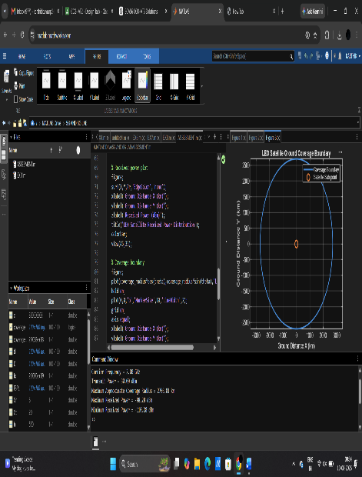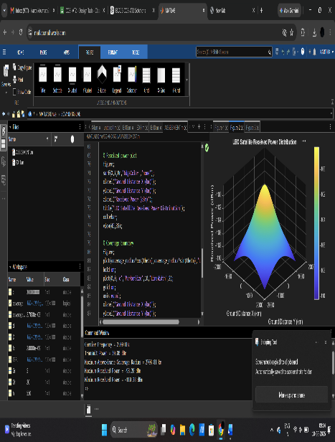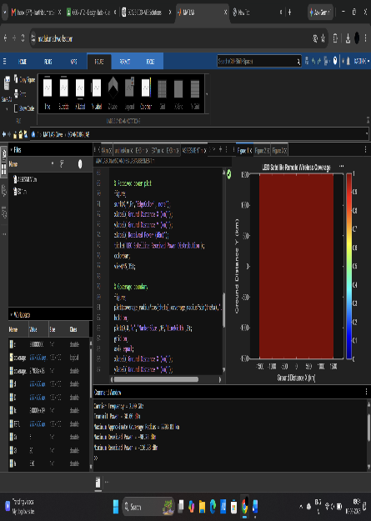

2.
AIM :
To develop and simulate a task offloading strategy between edge and cloud servers in a 5G network by selecting the processing location based on communication and computation latency, thereby minimizing overall task execution delay.
CODE :
clc; clear; close all;

% 5G Edge-Cloud Task Offloading Strategy

N = 100; % Number of tasks
rng(1); % Reproducible results

% Task parameters
task_size = randi([10 100],1,N); % Task size (MB)
cycles = randi([1 10],1,N); % Required computation (Giga cycles)

% Edge parameters
edge_speed = 5; % Edge processing speed (GCycles/s)
edge_delay = 5; % Edge communication delay (ms)

% Cloud parameters
cloud_speed = 20; % Cloud processing speed (GCycles/s)
cloud_delay = 40; % Cloud communication delay (ms)

% 5G transmission rate
data_rate = 1000; % Mbps

% Transmission delay
trans_delay = (task_size * 8) ./ data_rate;

% Edge computation delay
edge_comp = (cycles ./ edge_speed) * 1000;

% Cloud computation delay
cloud_comp = (cycles ./ cloud_speed) * 1000;

% Total delay
edge_total = edge_delay + trans_delay + edge_comp;
cloud_total = cloud_delay + trans_delay + cloud_comp;

% Offloading decision
decision = strings(1,N);

for i = 1:N
if edge_total(i) <= cloud_total(i)
decision(i) = "EDGE";
else
decision(i) = "CLOUD";
end
end

% Count decisions
edge_tasks = sum(decision == "EDGE");
cloud_tasks = sum(decision == "CLOUD");

% Average latency
selected_delay = zeros(1,N);

for i = 1:N
if decision(i) == "EDGE"
selected_delay(i) = edge_total(i);
else
selected_delay(i) = cloud_total(i);
end
end

avg_delay = mean(selected_delay);

% Results
fprintf('Total Number of Tasks = %d\n',N);
fprintf('Tasks Processed at Edge = %d\n',edge_tasks);
fprintf('Tasks Offloaded to Cloud = %d\n',cloud_tasks);
fprintf('Edge Task Percentage = %.2f %%\n',(edge_tasks/N)*100);
fprintf('Cloud Task Percentage = %.2f %%\n',(cloud_tasks/N)*100);
fprintf('Average Selected Latency = %.2f ms\n',avg_delay);

% Display first 10 task decisions
fprintf('\nTask\tSize(MB)\tEdge(ms)\tCloud(ms)\tDecision\n');

for i = 1:10
fprintf('%d\t%d\t\t%.2f\t\t%.2f\t\t%s\n', ...
i,task_size(i),edge_total(i),cloud_total(i),decision(i));
end

% Plot 1: Edge vs Cloud latency
figure;
plot(1:N,edge_total,'LineWidth',1.5);
hold on;
plot(1:N,cloud_total,'LineWidth',1.5);
grid on;
xlabel('Task Number');
ylabel('Total Latency (ms)');
title('Edge vs Cloud Processing Latency');
legend('Edge','Cloud');

% Plot 2: Offloading decisions
figure;
bar([edge_tasks cloud_tasks]);
grid on;
xticklabels({'Edge','Cloud'});
ylabel('Number of Tasks');
title('Task Offloading Distribution');

% Plot 3: Selected latency
figure;
plot(1:N,selected_delay,'LineWidth',1.5);
grid on;
xlabel('Task Number');
ylabel('Selected Latency (ms)');
title('Latency After Task Offloading');

OUTPUT :
